Primary Palliative Care for Emergency Medicine (PRIM-ER) A National Institutes of Health funded project led by NYU School of medicine
NYU EM Talk
Facilitator & Actor Booklet

Fall 2019
2019

Contents
Case 1. Respiratory Insufficiency in a Lung Cancer Patient 3
Case 1: Learner Presentation 7
Case 2. Goals of care in frailty/dementia patient with decline 8
Case 2: Learner Presentation 11
Actor Training Roadmap 12
REMAP Mnemonic Explained 13
NURSE Mnemonic 14
Room Configuration Guide 16
Main Room 16
Breakout rooms 16
Other considerations 16
Small Group Start-up Guide 17
Facilitation Map v7.0 18
Facilitator Skills Glossary 19

Case 1. Respiratory Insufficiency in a Lung Cancer Patient

Background
Patient: John Jacobs

John Jacobs is a 59 year-old-male with history of non-small cell lung cancer who presents to the emergency department via ambulance due to shortness of breath and chest pain.

John was diagnosed with non small cell lung cancer about two years ago. At that time, he presented to the hospital with fever and shortness of breath. He was found to have a right middle lobe obstructive pneumonia and a CT scan revealed an underlying mass. As his disease was stage I, he was treated aggressively a RUL lung resection and radiation to the chest and recovered well.

Last year, however, John developed back pain and imaging revealed diffuse spinal metastases. A biopsy confirmed that his lung cancer had returned and was now stage IV. He was started on chemotherapy and underwent radiation to his spine. Despite aggressive treatment, repeat imaging showed progression of his disease. In the last several months, he has also developed recurrent right malignant pleural effusions that have required frequent thoracenteses.

Three weeks ago, he was admitted for neutropenic fever and developed septic shock secondary to MSSA bacteremia. He was in the ICU though ultimately stabilized with antibiotics, fluids and pressors. Palliative care was consulted to address goals of care. There was a family meeting during which John’s oncologists recommended discontinuing chemotherapy and encouraged John to enroll in hospice. They documented in their note that his performance status was poor, that his cancer was not amenable to novel immunotherapy agents and that further chemotherapy was likely to do more harm than good. He was discharged home 5 days ago with home health as he and his brother/sister wanted a few days to think about it and said they would reach out to the oncology social worker when ready to transition to hospice.

This morning, John awoke with severe shortness of breath and right sided chest pain. His brother came over to the house to check on him and found him clammy and gasping for air, so he called 911.

Emotion & Personality:
He is a personable and sociable guy, was a high school biology teacher before he got sick and was very active in the school community both through his teaching and running several extracurricular clubs including a Health Careers club. He also loved tennis and enjoyed being the assistant coach of the JV team at his school. Because he did not have children of his own he always said that his students were like his own children and really prided himself on helping set them up for success in the future. He also loves animals and has spent some time volunteering locally at the animal shelter especially to get his mind off his divorce a few years ago. That is when he got his rescue dog, Roscoe, who has since been a steadfast companion for him during treatments and while he’s home.

Since John lives alone, his progressive weakness and fatigue have been particularly distressing to him. He has had increasing difficulty getting around the house, bathing himself and even making it to the bathroom on his own. His brother/sister has tried to get him to move in with he/she and his/her family but John is stubborn and prideful and does not want to be a burden on them.

Spirituality
- Raised Catholic but does not go to church except at Christmas, not spiritual.

Family/ Social History
- John lives alone, his sibling Michael/Michelle about 2 miles away in the same town
- Mother died of complications from diabetes in her 70s, and father died of MI in his 70s.
- Divorced 8 years ago, no children, has a 4 year old golden retriever named Roscoe

Surrogate: Michael/Michelle
Emotion & Personality:
Michael/Michelle is John’s middle age sibling and only other family in the city. Michael/Michelle is an architect with a firm that designs commercial spaces for new environmentally friendly buildings. S/he is Michael’s medical and financial power of attorney.

As an architect and an MBA Michael/Michelle is analytical, data driven, detail oriented and prides themself on having kept track of all the care John has been getting. Michael/Michelle is protective of John. S/he has been very detailed-oriented about all of John’s medical care and has avoided dealing with the emotional pain of John’s impending loss. S/he always has a lot of questions for the health care team and can be perceived as a bit aggressive and anxious when there are a lot of options presented, getting “into the weeds” with what they all mean.

Spirituality
Protestant
- Family goes to church on holidays, not religious

Family
- Married, they have 2 children, 8 and 10 year olds

Main life concerns
- S/he and their spouse have a good relationship, and Michael/Michelle is devoted to providing for their family and being there for their kids activities.
- With John’s illness, s/he has struggled with time management, being able to spend time with John, go to the doctor’s appointments, and be able to be with their own family.
- John’s ex-wife Donna is not involved and Michael/Michelle is the primary point of contact to update their extended family. Michael/Michelle’s way to cope with anxiety and sadness has been control.
- His/her workplace is busy with new contracts and development in converting a new area of town into green buildings and s/he has turned down some overtime this past year
- S/he visits John every day for at least an hour, and has been bringing meals over most nights as John has declined.

Social
- They have not had a chance to establish many other relationships because they are either working, or spending time as a family.

Session I

Patient/family Profile:
- Emotions – anxious + frustrated + focused on details after news is given
Medical facts:
- Arrives on CPAP with improved respiratory rate, fairly confused, lacks decisional capacity

Communication Environment:
Where: Outside ED treatment room
When: 1 hour after presentation

Communication Challenge/ Task(s): discuss goals of care
Interaction issues/ Hurdles
Sibling Michael/Michelle

- S/he is processing cognitively, repeating same questions about lab results and asking when they can do another thoracentesis or start chemo again
- S/he is not sure about what the next steps will look like and is focused on getting another thoracentesis done and maybe restarting chemotherapy since “it made him better the last time”
- If the learner gives a lot of medical facts with jargon or doesn’t deliver the message that “we are in a different place” s/he will remain focused on details asking about medical options like re-starting chemotherapy or doing another thoracentesis. He will not “absorb” the bad news if it is delivered without skill and empathy
  - If the learner delivers a clear headline “this isn’t like the last time”, “he is much sicker than before”, “the chemo isn’t working anymore and I’m worried the cancer is worse,” “I’m worried he is dying” Michael/Michelle will become more receptive to the idea and dials down the emotion level
- If the learner responds to emotions “I can only imagine how painful this must be for you?” “You must be so disappointed by everything that has happened.” “I can only imagine how sad you must be.” Michael/Michelle will let their guard down and share how scared they are
  - If the learner doesn’t respond to the fear and shock, Michael/Michelle will continue to express denial about the news that John may die soon. Anxiety will increase.
  - If the learner doesn’t respond to the emotions, s/he will continue to escalate, “Don’t you people even know what you’re doing?”
- If the learner asks about John as a person, “what is he like”, “tell me more about him” “What does John think about all of this.” “What would John tell us if he was standing next to me right now?” or even direct questions would be ok “Have you and John had a chance to talk about what’s most important to him at this point in his illness?” Michael/Michelle can start giving details of his personality and goals
  - If asked what John might say or think about the future Michael/Michelle may disclose that they were approached about starting hospice in the hospital last week but just weren’t “ready to give up” even though they thought it sounded like it might be more in line with John’s goals
  - They may also acknowledge that the medical team told them the chemo wasn’t working and the pleural effusions will continue to increase in frequency
  - He/she may note how distressed John was about not being able to take care of himself. He/she will describe John as someone who values his physical strength and independence. He will also verbalize that John had just mentioned when they got home that he’s tired of being in the hospital and “fighting” and was giving more thought to enrolling in hospice but that Michael/Michelle had tried to talk him out of it
- If he/she able to give info above about John not wanting to fight anymore/wanting to enroll in hospice, learner can recommend that they re-focus efforts on John’s comfort and not escalate to invasive therapies, instead focus on allowing him to die with comfort and dignity
- Michael/Michelle will agree that this is what John wants at this point

Case 1: Learner Presentation
Patient: John Jacobs
Sibling/Surrogate: Michael/Michelle Jacobs

CC: SOB

This is a 59-year-old male with complaints shortness of breath and chest pain

Paramedics were called to the patient’s house by his sibling who found the patient acutely dyspneic and more confused. They panicked and called 911
Initial vitals: HR 120 ST BP 170/60 RR 35 Sats 78% on RA
Patient was found to be in significant respiratory distress appearing chronically ill and confused. Medics started CPAP, gave an albuterol neb, and started an IV with some improvement.

Vitals on arrival to ED: HR 115 BP 155/60 RR 28 Sats 89% on BIPAP settings 15/5 100% FiO2 Temp 37.2

In the ED a stat CXR shows nearly 75% white out of the right lung with pleural effusion. Labs are near the patient’s recent baseline.

On chart review you find the patient has a history of non-small cell lung cancer, initially stage I at time of diagnosis 2 years ago, treated with radiation and a lung resection. Last year, spinal metastases were discovered and the patient subsequently developed recurrent right pleural effusions. He was been treated with chemotherapy and his effusions have been managed with frequent thoracenteses. Recent imaging has demonstrated progression of his disease.

Three weeks ago, he had a complicated hospital course during which he developed septic shock secondary to MSSA bacteremia in the setting of neutropenia. During this hospital stay his oncologists noted that he was no longer a candidate for more chemotherapy due to his weakened state and infections. Along with palliative care, they had a family meeting at which time hospice was recommended, but the family “wasn’t ready”. He was discharged home 5 days ago with home health care/nursing.

Patient remains fairly confused on BIPAP able to follow commands intermittently but not able to converse and appears somewhat delirious. You start arranging admission to the ICU but they are full and read the notes about hospice in the chart from last time so want you to address goals of care with the family before they come down.

His sibling Michael/Michelle Jacobs arrives 1 hour after ED presentation & wants an update.

Your task is to update John’s sibling on the situation and discuss goals of care

Case 2. Goals of care in frailty/dementia patient with decline

Background
Patient: Timothy Whitehouse

Timothy Whitehouse is an 85 year-old-male with multiple medical problems including dementia, diabetes, hypertension, coronary artery disease, atrial fibrillation who comes to the emergency department with altered mental status. He has had 5 admissions in the last 6 months from his skilled nursing facility for UTIs, altered mental status, dehydration, and aspiration pneumonia.

Timothy has had a progressive functional and cognitive decline over the past year and the last 2 admissions involved recurrent aspiration pneumonia. Despite attempts at rehabilitation with speech and physical therapy, a PEG tube was ultimately placed for nutritional support during his last admission to the hospital. He was discharged 1 month ago and since then hasn’t been able to get out of bed. He is incontinent. He seems to have lost interest in participating in any activities. Jamie, his 40 year-old child is most involved with his medical care, lives locally and is also Timothy’s power of attorney for healthcare.

This past week, the nurses have noticed that Timothy has been sleeping more hours of the day and when awake is less interactive.

This morning the nurses checked on him and found him more confused and agitated, with a temp of 102 and mild respiratory distress with an O2 sat of 90%. They called the patient’s daughter who said she wanted the patient transported to the hospital. 911 was called.

When he arrived to the ED, a sepsis work-up was initiated and he was ultimately determined to have a UTI and AKI. He was treated aggressively with IV fluids and antibiotics but 2 hours into his ED stay, he became hypotensive and his breathing became more labored, likely representing septic shock. Decisions about the use of central lines/intubation need to be made.

Emotion & Personality:
- Timothy was known as a comedian, a flirt and a jokester and is a retired attorney for local regional banking firm.
- He and his wife Millie were very active and went on yearly family vacations; they especially liked taking guided tours of different countries in Europe and Asia. He prided himself on being great at Jeopardy and trivia and loved the NYT crossword.
- In retirement he got into gardening and he and Millie volunteered with the local community garden. He was learning how to cultivate Bonsai trees in retirement. He hung out with his old law school buddies and played golf at least once a week where they would hang out at the clubhouse and have lunch.

Spirituality
Raised Protestant, previously active in his church, went to 1 mission trip to Honduras after he retired from work.

Family/ Social History
- Married to Millie, his high school sweetheart. Millie is currently residing in the assisted living section of the nursing facility and has some mild cognitive impairment, has been involved with Timothy’s care and stays with him during the day but defers the medical decisions to her daughter who is his Power of Attorney
- Served in Vietnam
- Has 3 children, Jamie (who lives in town and helps them the most), Veronica (38 year old lives in NYC investment banker), and Beth (34 year old who lives in town with Jessica, is single, and is an administrative assistant).

Son/Daughter: Jamie Millhouse
Emotion & Personality:
Jamie Millhouse is the 40 year-old eldest child of the patient, Timothy. She is a security guard in a small community hospital. S/he is married with 2 children, a 3 and 5 year-old, with a spouse that travels for work a lot (pharmaceutical sales), so sometimes s/he feels overwhelmed trying to take care of both her parents, her kids, and work.

Over the past year, Jamie took on the medical power of attorney for his/her parents’ care, his/her sister Veronica in DC was listed as the financial power of attorney. S/he and the siblings have a good working relationship, mostly through FaceTime and texting because of the distance. S/he is grateful for her sister Beth who lives in the same town and has regular 9-5 work hours. She can help out with her children their work schedule gets too complicated or Jamie’s spouse is out of town.

The past year has been very trying for Jamie: s/he is irritable, anxious, and tearful quickly. S/he takes a lot of pride in having kept Timothy and Millie together and helped them with their care but the stress has taken a toll.

Education
Jessica has an associate’s degree in psychology and has worked for 10 years at the local community hospital as a security guard.

Spirituality
- Protestant
- Jamie’s family goes to church every Sunday, and they get support from the church community and takes comfort in a bible study group that they attend when they can

Family
- Sisters Veronica 38 years old in DC and Beth 34 years old in town
- Spouse works in pharmaceutical sales for 10 years with two children 3 year old Robert “Bobbie” and 5 year old Rachel

Other stresses/ Main life concerns
Works as a security guard in a community hospital that is pretty busy, always coordinating schedules with his/her spouse who travels most of the time for work in pharmaceutical sales.

Session I
Patient/family Profile:
Emotions – initially anxious, sad/tearful, all related to anticipatory grief
Secondary hurdle of guilt, s/he was just trying to be a good child to dad and feels like s/he is failing – worried there’s something she could have done to prevent his current situation

Communication Environment:
Where: outside ED treatment room
When: 2 hours after presentation

Interaction issues/ Hurdles
Power of attorney/adult child Jamie
Jamie initially seems reasonable but anxious, putting on a “strong” front, “staying positive”, “we can get through this, he’s been able to get through things before” and using faith based support “we’ve been praying for him” “It’s in God’s hands”
- S/he is anxious and sad that he continues to have set backs, but doesn’t seem to “get it” as she states that he will likely bounce back after some IV antibiotics
- If the learner starts by giving a big picture update (recurrent infection, 2/2 dementia, critically ill,) she will listen; if the learner uses lots of jargon and details to start, she will become detail oriented, too, and start to ask about WBC counts and renal function
- If the learner attempts to learn about Timothy, in terms of his QOL, personality (very independent, his intellectual abilities were critical to his QOL), she will respond honestly and admit that recently he has had a terrible QOL
  - She will disclose that her father “never wanted to be this way” and that his current existence would be “his worst nightmare”
- She will respond even better if the learner gives her emotional support for her caregiver role (acknowledges how hard this all must be on her/tells her what an incredible job she’s been doing managing all of her parents’ medical issues) – she might even cry, say “thank you. I’ve been feeling like this was in some way all my fault because I put him in a NH” and ask the learner “what do you think we should do?”
- If code status type questions are brought up too soon, s/he will escalate and get defensive/mistrustful, get stuck in medical details, refer to religion and miracles – but if code status/use of life-sustaining interventions like central line/intubation are discussed AFTER QOL and/or emotional issues have been addressed, daughter will be ok discussing and will say that her father would never want “heroic things used” in his current condition.

Case 2: Learner Presentation
Patient: Timothy Whitehouse
Child/surrogate: Jamie Whitehouse

CC: Altered mental status

EMS arrives with an 85 y/o m, who has a h/o dementia, CAD, DM, HTN, a fib. They were called to the NH for AMS and fever. They report VS of temp 102 HR 120. BP 90/50. RR 30 O2 sat 88% in the field. They started an IV, gave a 500 cc fluid bolus and placed him on a NRB en route.

On arrival, the patient is awake, responsive to verbal stimuli, able to follow simple commands. He is ill-appearing in moderate respiratory distress. His VS on arrival are temp 102, BP 80/50, RR 25. O2 sat 97% on NRB.

PMH: dementia, HTN, CAD, DM, BPH
Home Meds: Aricept, Amlodipine, Aspirin, HCTZ, Metformin, Terazosin

Review of the Nursing Home paperwork reveals that Timothy is dependent in all his ADLs. His baseline cognitive status: he is oriented to self but not time or place. There are no advance directives.

ED Course:
You initiate a sepsis work-up on Timothy in the Emergency Department. Your work-up reveals a UTI (+blood +LE +nitrites +WBC), CXR with no infiltrate, Cr 2.2 (up from 1.2 last admit) and a WBC of 16. Timothy is given 2L crystalloid, Tylenol, and broad-spectrum antibiotics are initiated to cover urosepsis.

2 hours into his ED visit, the nurse calls you to the bedside because his BP is 70/30 despite receiving 2500ml NS so far. His oxygen saturation is 85-88% on a NRB. You are considering initiation of BIPAP vs intubation and whether a central line should be placed.

At the same time his medical POA Jamie Whitehouse arrives and wants an update.

Your task is to update Jamie on the medical information and discuss goals of care

Actor Training Roadmap

1. Ask the actor if they have questions about the medical aspects of the case. Don’t spend too much time on this step, the medical details of the case are important to lead the actor’s emotional state, motivation, and backstory.

2. Ask the actor if they have questions about what kind of person their character is in terms of biography or personality. Can they articulate their main emotion in a few words or a sentence?

3. Talk to the actors about what you need from them:
1) To set the emotional temperature of the room by inhabiting the character.
2) To help learners see that if their response changes, the patient will change too.
3) To respond genuinely to the learners. Explain how this is different than being a standardized patient.

4. Walk through the case – have the other faculty person do a “bad” job (e.g. the faculty should not show the skills you are trying to teach). Start rehearsing, actors need to learn by doing, not by being told what to do.
Start with a less skilled doctor.
a) Does the actor show the emotion that you want addressed?
b) Does the actor show an appropriate level of emotion?
c) Does the actor raise the emotional intensity in the face of less skilled behavior, and then lowering intensity, in response to more skilled behavior?

5. Walk through the case again - have the other faculty person do a “skilled” job (e.g. the faculty should show the skills you are trying to teach).
a) When the faculty person uses the skill does the actor decrease emotion or give more information - even if the skill is not done “perfectly”? (e.g. reward the learner for behavior)
b) Does the actor have a sense of where to go in the story if the learner uses the desired skill(s)? (e.g. does the learner know where the story is going and what the limits of the story are?)
6. Check-in to see what questions the actor has about their character after the training. These questions may lead you to make modifications in the case that should be sent to the actors.

7. Show the actors the entire sweep of a teaching encounter (time out, feedback, finding educational opportunity, redo and summary) so the actor sees the rhythm of the teaching session. Talk to them about going into neutral during the non-acting time, the importance of coming back to the encounter in the redo with the same emotionality

8. Give feedback to the actor.
a) Focus on their mind-set or character more than specific words
b) It often helps to direct them to show emotions through their non-verbal physicality
c) Tell them what you like about what they are doing!
d) Remind them that even if the fellow does not do the skill perfectly, they should respond (One way to indicate this to them in “actor-speak” is to make a parallel with working with a “bad actor” to improve).
e) Talk about what to do if they see the participants outside of the session during the course
f) Talk about the logistics of when to show up, etc.

REMAP Mnemonic Explained
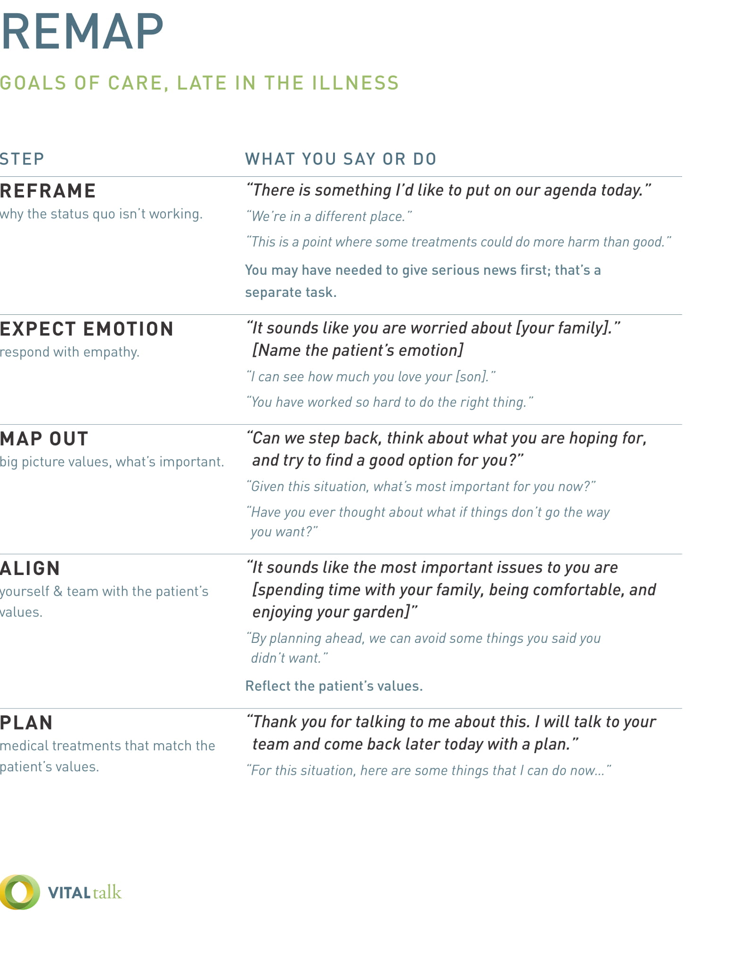

NURSE Mnemonic

For Facilitator’s Only

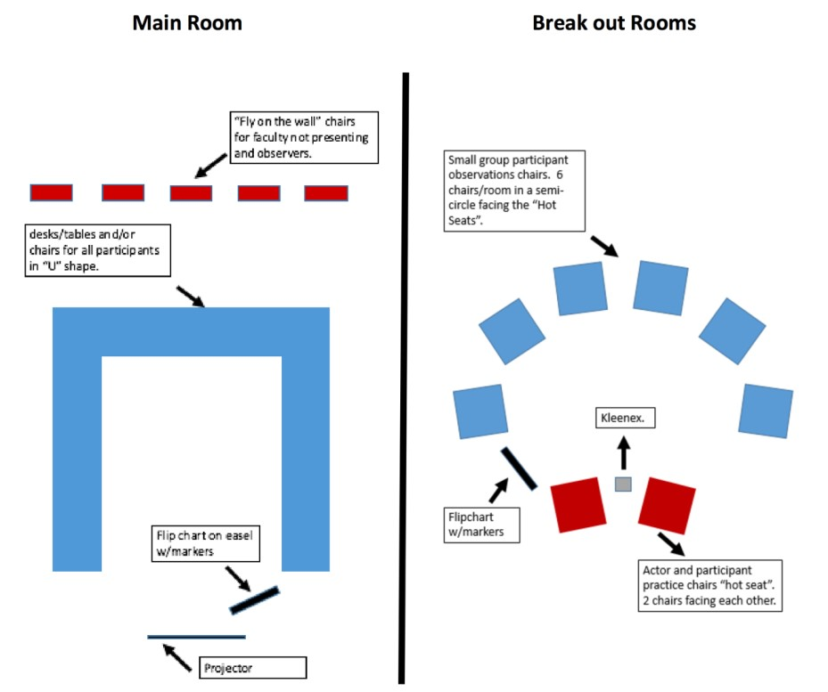
Room Configuration Guide
Please use the suggested guide for setting up the rooms

Main Room
- The main room should have enough space to comfortably seat all participants and faculty/staff.
- We ideally like to have a “U” shape for participants to sit in; if this isn’t possible another “open” style arrangement is preferred, as opposed to rows of chairs/desks.
- Make sure projection is available with audio capabilities (use a microphone if necessary).

Breakout rooms
- The breakout rooms should only have chairs in a semi-circle facing 2 chairs, which are for the patient and the learner (“hot seat”). No tables or desks should be used.
- If possible, use a room where you can tape flip chart paper to the walls.

Other considerations
- When selecting an event location, consider a place that will provide a quiet atmosphere that is conducive for intimate learning. The rooms should be separate from “other activities” as sometimes simulated patients can be loud.
- Travel between the main room and break-out rooms should be simple.
- Meals: consider having a space for meals, if this is going to be in the main room, make sure set up/take down can be done at break times as to not disturb any meeting times in the main room.
- Breaks: we suggest building in breaks throughout the course, with a clear space for participants to congregate.
- Green Room: Actors will need a space they can go to when they are not in session. This can be another room or just a lounge area that is away from the main event.

Small Group Start-up Guide
This guide was designed to help successfully set your small group up for learning.
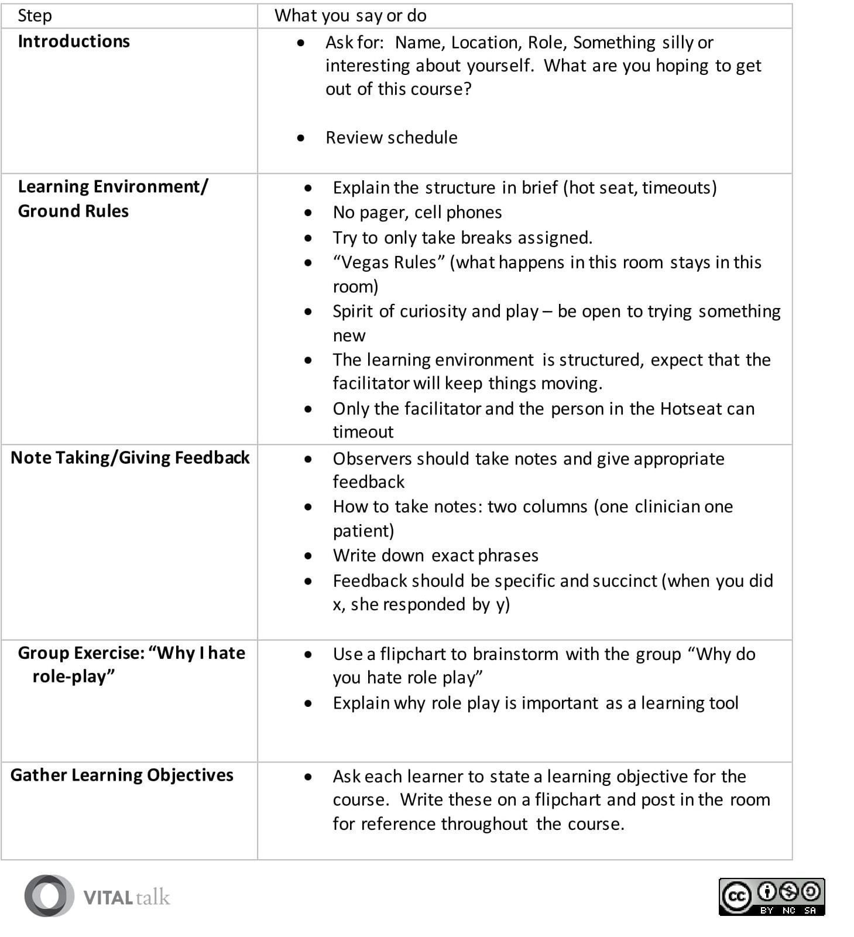

Facilitation Map v7.0

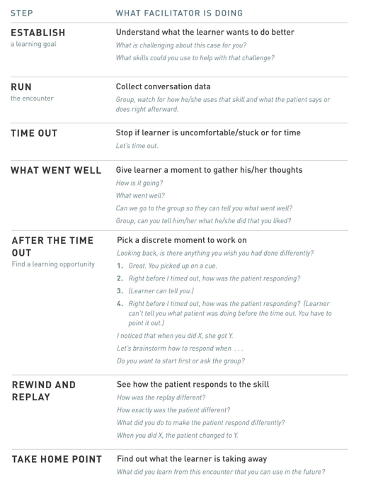

Facilitator Skills Glossary
