2019
End-of-Life Nursing Education Consortium
NYU Langone Medical Center

Step 1: Login
Link: https://nyumc-primer.sabacloud.com/Saba/Web_spf/NA3P1PRD0091/common/leclassview/dowbt-000219233
Username: Your login username will be your University Hospital email address
Password: welcome.
- You will need to change this password upon your initial log-in.
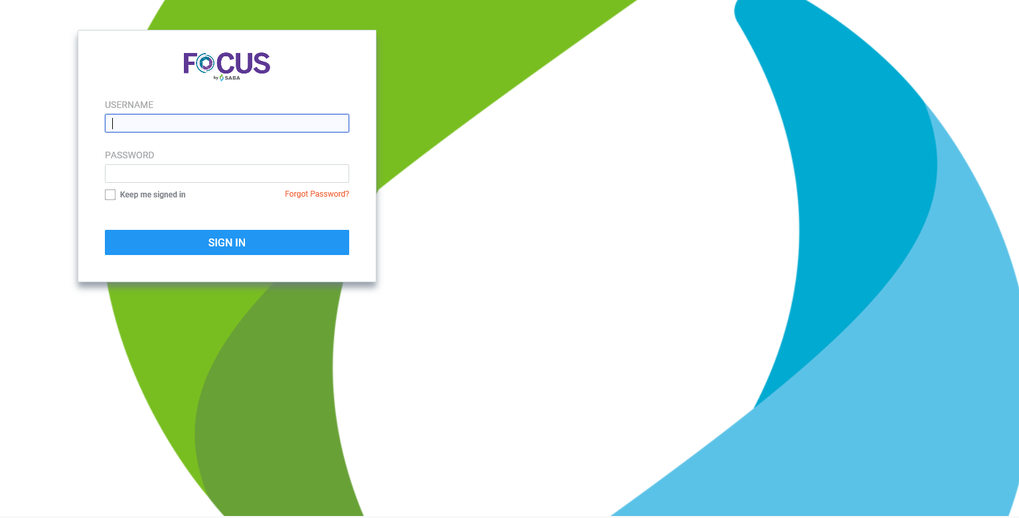

Step 2: Click Accept
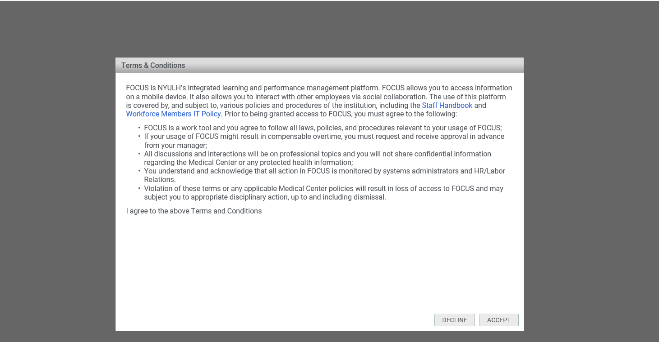

Step 3: click Enroll and the Activity “ELNEC_Final”
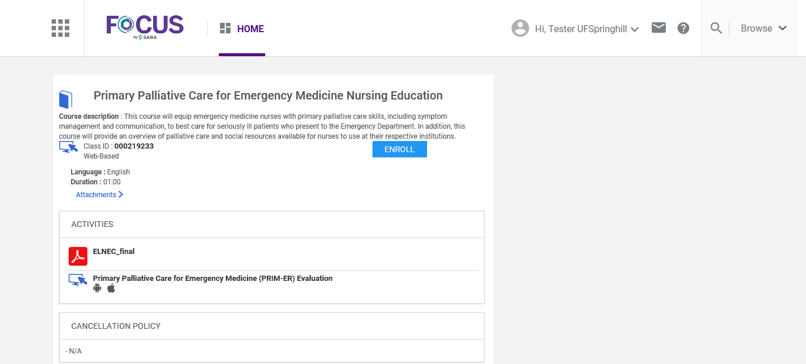
If you do not enroll you will not receive credit for the course

Step 4: After reviewing the course material click the “x” on the upper right to exit the course.
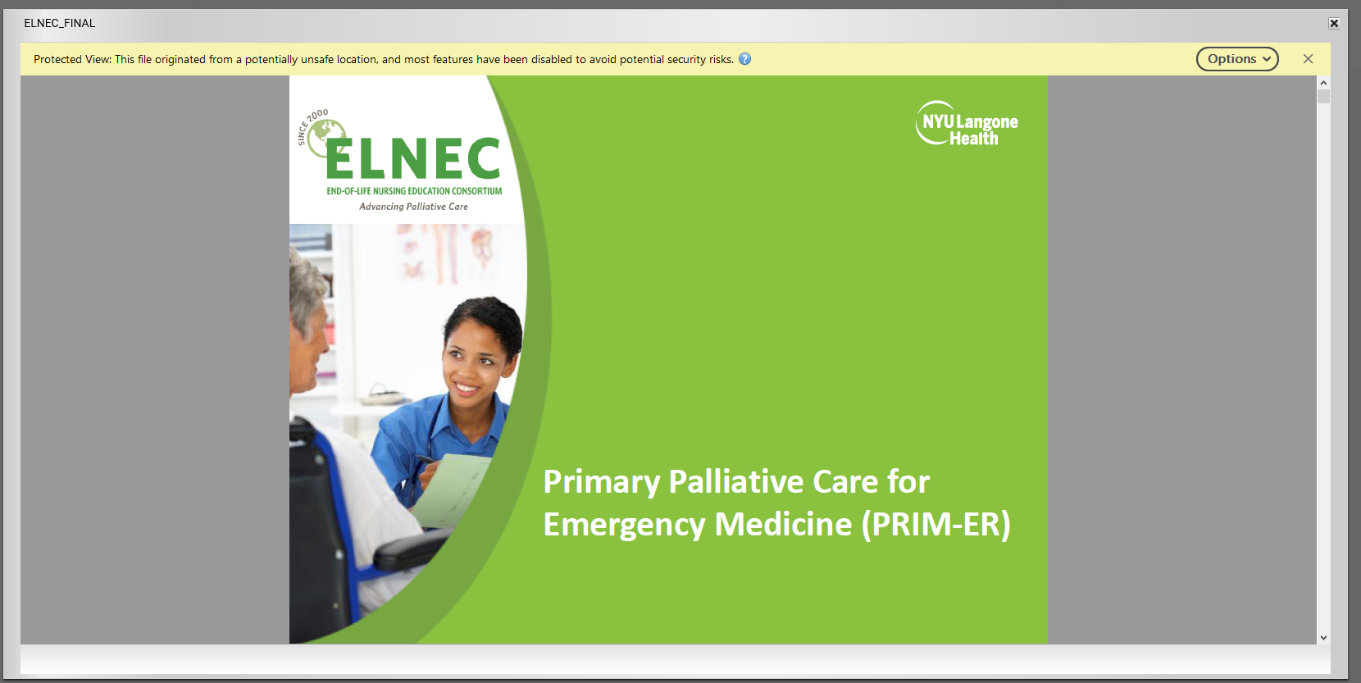

Step 5: You will be prompted to acknowledge that you read and understood the content of the course. Click the appropriate response option.
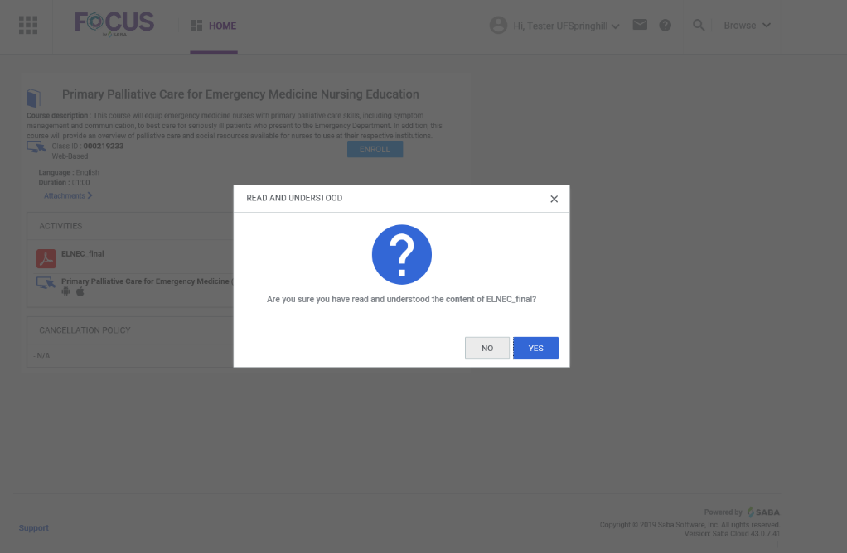

If yes, your screen will update to show that your course has been completed successfully.
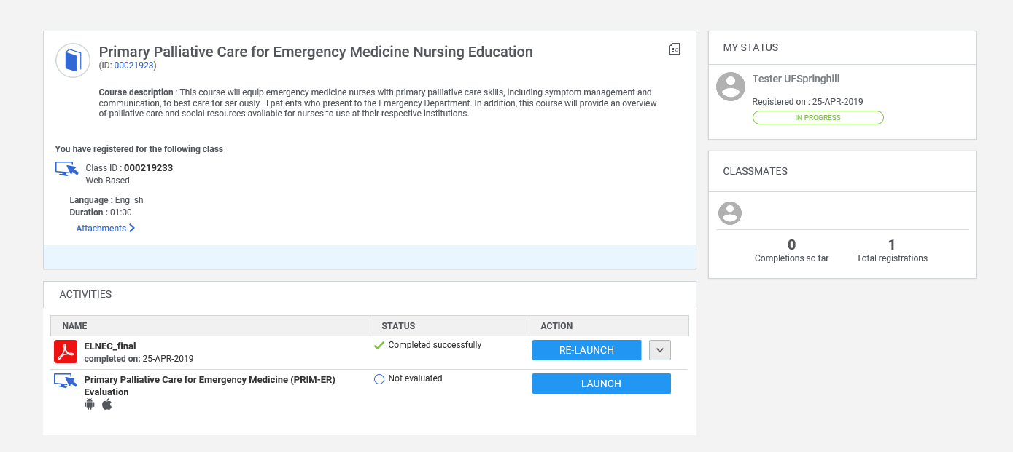

Step 6: Evaluation
In order to receive your 1 CEU credit and $50 Amazon Gift Card from NYU you need to complete the course evaluation. After taking this course this step is imperative. Click “Launch” and you will be prompted to start the brief 10 question evaluation. At the end of the evaluation make sure to click “Submit”
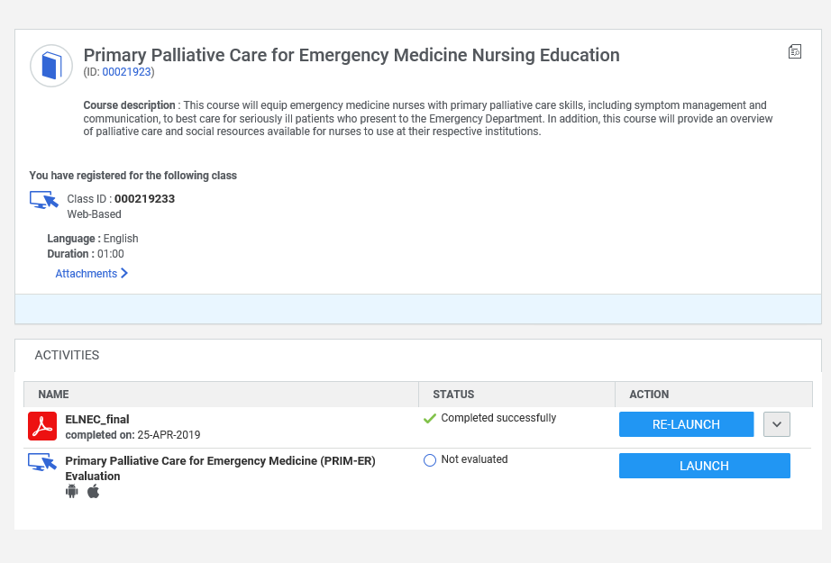

Step 7: Print or export certificate to keep on file for personal CEU records
